Fire Extinguishers
- Remove extinguisher from bracket
- Proceed to fire & operate extinguisher
- Ensure door or exit is directly behind you before operating extinguisher.

It is easy to remember how to use a fire extinguisher if you remember the “PASS” process.
Pull the Pin

This will allow you to discharge the extinguisher
Aim at the base of the fire
Hit the fuel…if you aim at the flames, the
Extinguishing agent will pass right through. (Approximately 2 metres safety distance)
Squeeze the top handle  This depresses a button that releases the pressurized extinguishing agent. | 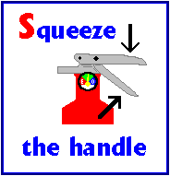
Sweep hose from side-to-side  Until the fire is completely out.  Start using the extinguisher from a safe distance away, and then slowly move forward. | 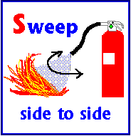

“REMEMBER- SAFETY OF PEOPLE IS THE PRIORITY, NOT THE BUILDING”

